DWDM LAB ASSIGNMENT SET 6

1)data set name –Mall_customer

Customer_id=numeric data

Gender=categorical data

Age=numeric data

Average income=numeric data

Spending score=numeric data

2)

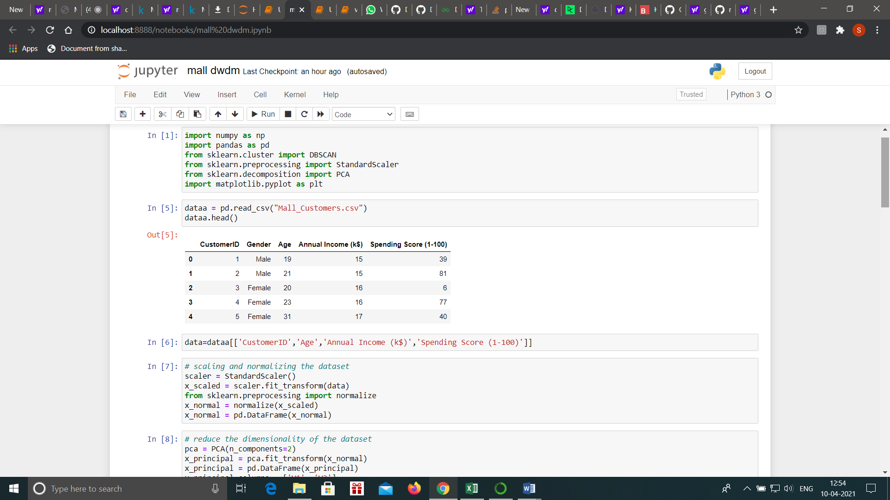

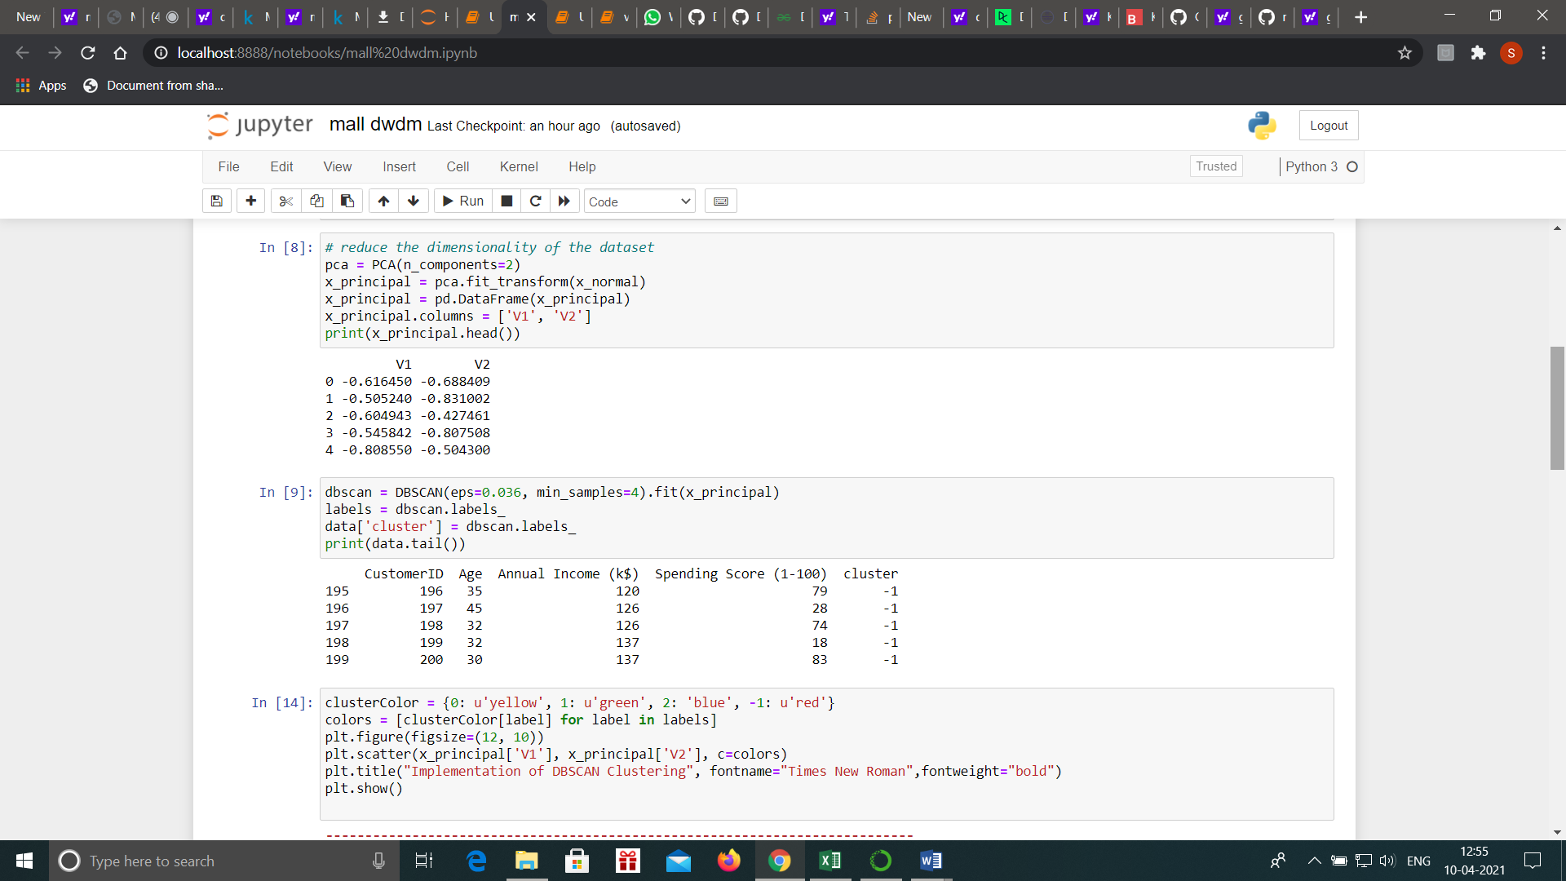

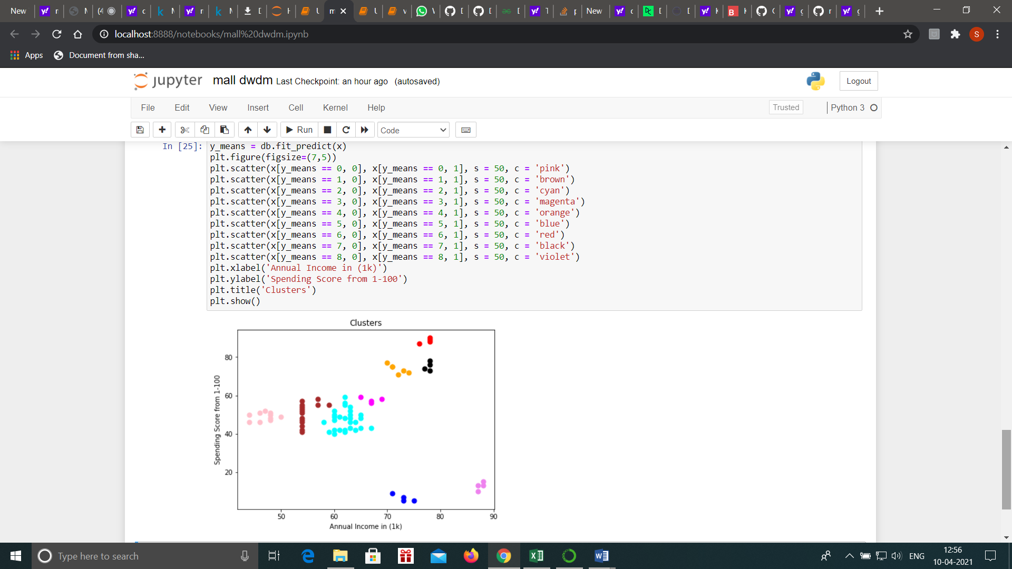

3)link for programs=https://github.com/sharankumarbalaji/lab-dwdm